KARACHI STOCK EXCHANGE
A Complete Analysis, on the Stock Market Functioning.



Submitted to: Dr. Salman Ahmad

Group Members:

- Muhammad Umair (L1F06MBBF2043)
- Muhammad Umair (L1F06MBBF2004)
- Shehzad Bashir (L1F06MBBF2001)
- Madiha Asad Mirza (L1F06MBBF1028)
- Syed Aqeel Abbas (L1F06MBBF2006)

Table of Content

- Introduction - Stock Exchange (Page # 3)
  - What is Stock Exchange?
  - First Stock Exchange of the world.
  - Purpose, Role & Importance of the Stock Exchange?
  - How Stock Exchange works?
  - Stock Exchanges in Pakistan.

- Introduction – Shares (Page # 6)
- What are SHARES?
- Why Do Companies Issue Shares?
- Why Do Investors Buy Shares?
- Various Ways of Becoming a Shareholder.

- How to Trade? (Page # 8)
- Introducing Stockbrokers.
- The Mechanics of Share Dealing.
- Opening of Account.
- Buying/ Selling Directly.

- Karachi Stock Exchange (Page # 9 )
- About KSE.
- Board of Directors.
- KSE Profile.
- KSE – Indices.
- List of Sectors.
- Top 10 Index Weightage Companies.
- Upper and Lower Circuits of shares.
- Performance of KSE-100 from April 17 to May 17.
- Trading and Settlement.
- Central Depository System - CDS
- Imposition of Tax (CVT & Withholding Tax)
- Implementation Of CFS Financing
- SCRA – (Special Convertible Rupee Account)
- 5 Years Progress 2003 - 2007

- Glossary of Stock Market Terms (Page # 22 )

Introduction – Stock Exchange

1 – What is Stock Exchange?

Introduction:

Everyone today appreciates the need to save whether for a house, for children’s education, a wedding, or for use after retirement. All these goals can be realized through excellent financial planning. An intelligent plan entails investing your money in an appropriate combination of assets with potential to generate the income needed to achieve your goals. If you invest wisely, you can maximize the earning on your investments.

There are many investment avenues available, but a wise investor does not invest on impulse, a hot tip or follow the herd. An investor should discriminate between information, casting away irrelevant and illogical pieces of information, and checking for opportunities and facts before making an intelligent choice of investments.

Definition:
The term 'the stock market' is a concept for the mechanism that enables the trading of company stocks (collective shares), other securities, and derivatives. Bonds are still traditionally traded in an informal, over-the-counter market known as the bond market. Commodities are traded in commodities markets, and derivatives are traded in a variety of markets (but, like bonds, mostly 'over-the-counter').
“Stock Exchange is an organized market for buying and selling financial instruments, such as stocks, debentures, bonds etc.”

The stock exchange provides a market place where shares can be bought and sold.

2 - First Stock Exchange of the World

The Amsterdam Stock Exchange is said to be the first stock exchange of the world to introduce continuous trade in the early 17th century.

In 1602, the Dutch East India Company issued the first shares on the Amsterdam Stock Exchange. It was the first company to issue stocks and bonds.

3 - What is the Purpose, Role & Importance of the Stock Exchange?

Purpose of the Stock Exchange:

The purpose of a stock exchange is to facilitate the exchange of securities between buyers and sellers, thus providing a marketplace (virtual or real). The exchanges provide real-time trading information on the listed securities, facilitating price discovery.

Role of the Stock Exchange:

- The stock exchange admits companies for trading at their securities.

- It provides a market for raising capital by companies.

- It provides a market place for shares of listed public companies to be bought and sold, by bringing companies and investors together at one place.

- The exchange’s role is to monitor the market to ensure that it is working efficiently, fairly and transparently.

Importance of the Stock Exchange:

The stock market is one of the most important sources for companies to raise money. This allows businesses to go public, or raise additional capital for expansion. The liquidity that an exchange provides affords investors the ability to quickly and easily sell securities. This is an attractive feature of investing in stocks, compared to other less liquid investments such as real estate.

History has shown that the price of shares and other assets is an important part of the dynamics of economic activity, and can influence or be an indicator of social mood. Rising share prices, for instance, tend to be associated with increased business investment and vice versa. Share prices also affect the wealth of households and their consumption. Therefore, central banks tend to keep an eye on the control and behavior of the stock market and, in general, on the smooth operation of financial system functions. Financial stability is the raison d'être of central banks.

Exchanges also act as the clearinghouse for each transaction, meaning that they collect and deliver the shares, and guarantee payment to the seller of a security. This eliminates the risk to an individual buyer or seller that the counterparty could default on the transaction.

The smooth functioning of all these activities facilitates economic growth in that lower costs and enterprise risks promote the production of goods and services as well as employment. In this way the financial system contributes to increased prosperity.

4 – How the Stock Exchange Works?

- Actual trades are based on an auction market where a potential buyer bids a specific price for a stock and a potential seller asks a specific price for the stock. (Buying or selling at market means you will accept any bid price or ask price for the stock).

- When the bid and ask prices match, a sale takes place on a first come first served basis if there are multiple bidders or askers at a given price.

5 - Stock Exchanges in Pakistan.

There are three stock exchanges in Pakistan:
- Karachi Stock Exchange (Guarantee) Ltd.
- Lahore Stock Exchange (Guarantee) Ltd.
- Islamabad Stock Exchange (Guarantee) Ltd.
Of these, Karachi Stock Exchange is the biggest exchange in the country.
Introduction – Shares

1 - What are SHARES?

Each share represents a small stake in the equity of a company. You can buy large or small lots to match the amount of money you want to invest. A company’s share price can rise or fall as a result of its own performance or market conditions.
Once the shares are brought and transferred in your name your name will be entered in the company’s share register, which will entitle you to receive all the benefits of share ownership including the rights to receive dividends, to vote at the company’s general meetings to receive the company’s reports.

If you decide to sell your shares you will need to deliver share certificates to the broker in time for the transaction to be completed.

With the introduction of the Central Depository System (CDS), an investor can have shares in paper form or can own shares in an electronic book- entry form at the Central Depository Company (CDC).

2 - Why Do Companies Issue Shares?

Companies issue shares to raise money from investors. This money is used for the development and growth of businesses of companies.

A Company can issue different types of shares such as ordinary shares, preference shares, shares without voting rights or any other shares as are permissible under the law. These give shareholders a stake in the company’s equity as well as a share in its profits, in the form of dividends, and a voting right at general meetings of shareholders.

3 - Why Do Investors Buy Shares?

Studies have shown that over a twenty-year span, investment in shares has provided greater returns than most other forms of savings. Shares can provide you with a regular stream of income through dividends as well as the potential for your investments to grow in value. If the prices of shares go up, you can sell them for more than you paid. This is called capital gain.

4 - Various Ways of Becoming a Shareholder.

Initial Public Offering (IPO):

When companies offer shares to the general public for the first time it is known as a flotation or an Initial Public Offering (IPO). These shares can be bought directly from the company without paying stockbroker’s commission. You might see an advertisement in a newspaper from a company issuing shares or your stockbroker might tell you about a company making an IPO. Simply fill in the share subscription form and deposit the form along with subscription cheque in a branch of the designated bank(s).

Trading Market:

The most common way of buying/selling in stock market is through trading in the secondary market. Through a stockbroker you can buy shares from existing investors who wish to sell them and vice versa.

Right Issues:

Right shares are issued when companies need to raise additional capital to finance their new expansion projects or to meet working capital needs, etc. In case of rights issues, the existing investors have the right to subscribe to these new shares in proportion to their respective shareholdings.

How to Trade?

1 - Introducing Stockbrokers:

Stockbrokers are your link to the stock market. Their job is to help you get the best price available when you want to buy or sell your shares. Be careful in selecting your broker.

2 - The Mechanics of Share Dealing:

There are various ways of investing in the stock market: you can deal directly in shares; invest through a unit trust or investment trust or let your investment be handled by an advisor.

3 - Opening of Account:

Once you have decided the broker with whom you intend to deal, you should ensure that an account is opened in your name by filling the account opening form. It is imperative that the terms and conditions prescribed in the account opening form are read very carefully and well understood. It will be in your interest if you give clear instructions as to who can operate the account. It is preferred if the investor gives instructions that business can only be transacted in the account on his instructions.

4 - Buying/ Selling Directly:

When you have decided to buy/sell shares in a particular company, contact your stockbroker. You can ask to buy/sell a fixed number of shares or shares up to a certain value. Get the contract note confirming your order immediately and check for the following information.

a) Name and number of securities;
b) Date on which the order is executed;
c) Nature of transaction (spot, ready or forward and also whether bought or sold);
d) Price at which the transaction is executed; and
e) Commission charged by the broker.

Limit Orders: In a limit order, the client specifies the price at which the order is to be executed.
Market Order: Also known as at best order, the order is executed at the prevailing market rate.

Karachi Stock Exchange

1 - About Karachi Stock Exchange:

HISTORY

The Karachi Stock Exchange (KSE) came into existence on September 18, 1947. It was later converted into a registered company limited by guarantee on March 10, 1949. Though as many as 90 members were enrolled at that time, hardly half a dozen of them were active as brokers. Initially, only 5 companies were listed with a paid-up capital of Rs. 37 million.

From this modest beginning the Karachi Stock Exchange had become, by the end of December 1991, a key institution in the financial sector of Pakistan and today has a membership strength of 200 with almost 140 active members trading in 751 listed companies, having a list capital of Rs. 122.709 billion (US$ 4.0 billion) with a market capitalization of Rs. 355.359 billion (US$ 11.4 billion) as on October 31, 1996. There is an average daily turnover of approximately 13.0 million shares.

Trading takes place on an open outcry system. Each quoted security being traded in sequence. Bids and offers are shouted by members' trading clerks, with transactions being noted by KSE and recorded on board. When a bid and offer matches, a transaction takes place. Price movements are also relayed to members on closed circuit monitors. Karachi Stock Exchange is the biggest and most liquid exchange and has been declared as the “Best Performing Stock Market of the World for the year 2002”. As on January 31, 2007, 654 companies were listed with the market capitalization of Rs. 3,077.401 billion (US $ 50.70) having listed capital of Rs. 516.939 billion (US $ 8.516 billion). The KSE 100 Index closed at 11272.33 on January 31, 2007.

KSE has been well into the 6th year of being one of the Best Performing Markets of the world as declared by the international magazine “Business Week”. Similarly the US newspaper, USA Today, termed Karachi Stock Exchange as one of the best performing bourses in the world.

The market performing during the period June 1998 to January 31, 2007 is given under.

DECADEWISE PROGRESS
YEAR | NO. OF LISTED COMPANIES | LISTED CAPITAL  (Rs. in million) | MARKET CAPITALISATION  (Rs. in million)
1950 | 15 | 117.3 | -
1960 | 81 | 1,007.7 | 1,871.4
1970 | 291 | 3,864.6 | 5,658.1
1980 | 314 | 7,630.2 | 9,767.3
1990 | 487 | 28,056.0 | 61,750.0
2000 | 762 | 236,458.5 | 382,730.4

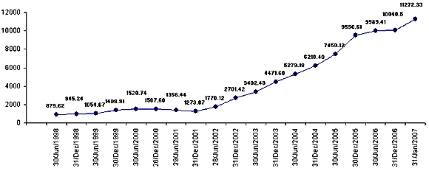

2 - Board of Directors:

The KSE is run by a Board of Directors that consists of 10 members including Managing Director. Out of these, 5 Directors are elected from amongst 200 members of the Exchange and 4 non-member Directors are nominated and appointed by SECP from amongst the professionals belonging to various trades and professions. The Chairman is elected by the Board from amongst the non-member Directors. The operational and administrative activities of the Exchange are managed by the Managing Director who is the full time Chief Executive of the Exchange.
Following are the members of the Board.
01 | Mr. Shaukat Tarin | Chairman
02 | Mr. Muhammad Yaqoob Memon | Acting Managing Director
03 | Mr. Muhammad Aliuddin Ansari | Director
04 | Mr. Sikander Esmail Bagasrawala | Director
05 | Mr. Shehzad Chamdia | Director
06 | Mr. Tariq Kirmani | Director
07 | Mr. Muhammad Shoib Memon | Director
08 | Mr. Muhammad Dawood Jan Muhammad | Director
09 | Mr. Asad Umar | Director
10 | Haji Ghani Haji Usman | Director

3 - Karachi Stock Exchange Profile :

Address | Karachi Stock Exchange (Guarantee) Limited  Stock Exchange Building, Stock Exchange Road  Karachi - 74000, Pakistan
Telephone | UAN: 111-00-11-22, 2425502-3
Web Site | www.kse.net.pk
Trading Hours | Monday through Thursday: 9.30am - 2.15pm  Friday: 9.30am - 12.00pm - first session  2.15pm - 4.00pm - second session
Holidays | Eid-ul-Azha, Kashmir Day (5 Feb), Ashura, Pakistan Day (23 Mar), Labor Day (1 May), Eid Milad-un-Nabi, Independence Day (14 Aug), Iqbal Day (9 Nov), Jummah-Tul-Widah, Shab-e-Qadar, Eid-ul-Fitr, Christmas (25 Dec), Eid-ul-Azha - total 20 holiday days.
Securities | Shares, bonds, Modaraba Certificates of listed companies, Unit trust schemes, mutual funds certificates, futures, indices.
Trading System | Karachi Automated Trading System (KATS)

4 - KSE – Indices:

What is index?

“Index is a benchmark by which the stock price performance can be compared to over a period of time”.

In particular it is designed to provide investors with a sense of how the market is performing.

KSE – Indices:

KSE began with a 50 shares index. As the market grew, a representative index was needed.

On November 1, 1991 the KSE-100 was introduced with a base of 1,000 points. By 2001, it had grown to 1,770 points. By 2005, due to a period of robust growth the index had skyrocketed to 9,989 points. It reached a peak of 12,700 points in May 2007. As at March 2007 it is currently trading at 12,310 points (May. 15, 2007). [1] The KSE-100 approach remains to this date the most generally accepted measure of the Exchange. The KSE-100 is a capital weighted index and consists of 100 companies representing about 86 percent of market capitalization of the Exchange.

At the end of 2006, KSE-30 index was introduced, which was Pakistan first free float index comprising of 30 most floated stocks in KSE. KSE-30 index was trading at 15,300 points (May. 15, 2007).

5 - List of Sectors:

Karachi Stock Exchange deals with the following sectors:

- Close-end Mutual Fund
- Modaraba
- Leasing Companies
- Inv. Banks / Inv. Cos. / Sec. Cos
- Commercial Banks
- Insurance
- Textile Spinning
- Textile Weaving
- Textile Composite
- Woollen
- Synthetics & Rayon
- Jute
- Sugar & Allied
- Cement
- Tobacco
- Refinery
- Power Generation & Distribution
- Oil & Gas Marketing Companies
- Oil & Gas Exploration Companies
- Engineering
- Automobile Assembler
- Automobile Parts & Accessories
- Cables & Electric Goods
- Transport
- Technology & Communication
- Fertilizer
- Pharmaceutical
- Chemical
- Paper & Board
- Vanapati & Allied
- Leather & Tanneries
- Foods & Personal Care Products
- Glass & Ceramics
- Miscellaneous

Out of the above mentioned sectors, the following sectors are called the pick of the market because of impressive volumes of shares traded.

- Commercial Banks
- Insurance
- Cement
- Refinery
- Power Generation & Distribution
- Oil & Gas Marketing Companies
- Oil & Gas Exploration Companies
- Technology & Communication

6 - Top 10 Index Weightage Companies:

COMPANY NAME | INDEX WEIGHTAGE
O. G. D. C. | 17.57
National Bank of Pakistan Limited | 6.68
P. T. C. L. “A” | 6.27
MCB Bank Limited | 6.11
Pakistan Petroleum Limited | 5.99
United Bank Limited | 5.08
Pakistan Oilfields Limited | 2.18
Pakistan State Oil Company Limited | 2.02
Sui Northern Gas Pipelines Limited | 1.36
Fauji Fertilizer Company Limited | 1.06

Explanation:

The pick of our stock exchange is the share of OGDCL. Its has higher Weightage towards the index. For example, if the share price of OGDCL is up by Rs.1 then it added 17.75 points towards the KSE-100 index. That is why it is called the “Giant of stock exchange”. Then we have NBP and PTCL contributing 6.68 and 6.27 points respectively towards the KSE-100 index.

7 - Upper & Lower Circuits of shares:

According to the regulations given by SECP, a share can rise or fall up to a certain limit in an intra-day trading. These limits are given below:

- If the market value of a share is from Rs.1 to Rs. 21, it has a cap of Rs. 1.
For example, if the market value of a share is Rs.15 then its upper circuit will be Rs.16 & its lower circuit will be Rs.14 during an intra day trading.

- If the market value of a share is above Rs.21, then its cap will b 5%.
For example, if the market value of a share is Rs.100 then its upper circuit will be Rs.105 and its lower circuit will be Rs.95 during an intra day trading.

8 – Performance of KSE-100 during April 17 to May 17, 2007:

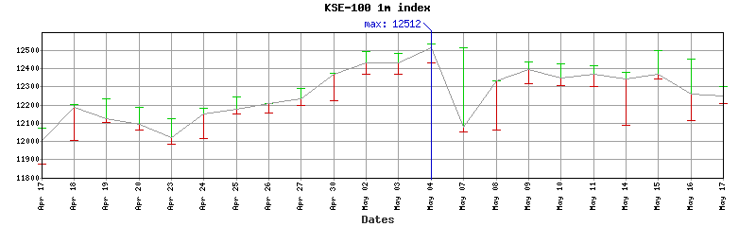

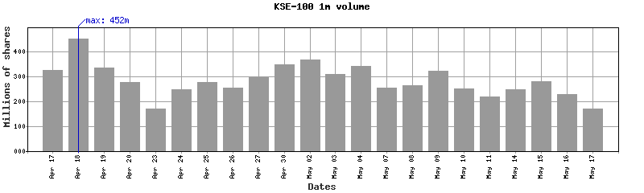
9 - Trading and Settlement:

The stock exchanges have introduced a computerized trading system to provide a fair, transparent, efficient and cost effective market mechanism to facilitate the investors.

The trading system comprises of four distinct segments, which are:

- T+3 Settlement System;

- Spot Transactions; and

- Futures Contracts.

T+3 Settlement Systems:

In the T+3 settlement systems, purchase and sale of securities is netted and the balance is settled on the third day following the day of trade.

Benefits of T+3 Settlement Systems
- It reduces the time between execution and settlement of trades, which in turn reduces the market risk.

- It reduces settlement risk, as the settlement cycle is shorter.

- Recently the board has approved T+2 settlement.

Spot/T+1 Transaction:

Spot transactions imply delivery upon payment. Normally in spot transactions the trade is settled within 24 hours.

Futures Contract:

A Futures contract involves purchase and sale of a financial or tangible asset at some future date, at a price fixed today.

10 - Central Depository System – CDS:

Electronic book-entry transfer of securities i.e. CDS has been set up to eliminate physical transfer of securities. This new book-entry system is in line with the international practice and has replaced the manual system of physical handling and settlement of shares at stock exchanges.

Presently, 97 percent of settlements are routed through CDS.

The CDS is managed by the Central Depository Company of Pakistan Limited, which has been sponsored by the stock exchanges and leading local and financial institutions.

The CDC is a company that operates an electronic share register called the Central Depositary System (CDS). The CDS eliminates the need for physical movement of share certificates. It has also solved investor problems related to stock handling on the settlement date, registration of shares, and exercise of corporate action benefits. Clients availing of our custodial services can open a CDS sub-account with Taurus, for which a form is included in the account application pack. Alternatively, they may wish to directly open an Investor Account with the CDC.

11 - Imposition of Tax (CVT & Withholding Tax):

The following taxes have been levied on equity investors in the Finance Bill 2004-05:

- Capital Value Tax (CVT)* @ 0.01% on the purchase value of shares.

- Withholding tax @ 0.005% on the sale value of shares.

* In the Finance Bill 2006-07, (CVT) rate has been extended from 0.01% to 0.02% on purchase of shares, whereas Withholding tax remains the same i.e. 0.005%.

Capital gains income from equity trading is tax exempt up to June 2007.

Stock dividends are treated as taxable income under Pakistan tax law.
Dividend income is subject to withholding tax; the paying company deducts the tax at source at various rates based on the recipient's status.

Certain Muslim investors are subject to Zakat (an Islamic wealth tax) on the value of their equity holdings as on the first day of the Holy Month of Ramadan. The paying company deducts the Zakat amount from the next dividend payment to shareholders.

12 - Implementation of CFS Financing:

In order to improve the liquidity in the capital market, it is expedient to introduce Continuous Funding in place of Carry over or badla financing.
NOW THEREFORE, in exercise of its powers under Section 34(1) of the Securities & Exchange Ordinance, 1969, the Karachi Stock Exchange (Guarantee) Limited with the prior approval of the Securities & Exchange Commission of Pakistan, hereby makes the following Regulations:

1. SHORT TITLE AND COMMENCEMENT

(1) These Regulations shall be called “The Continuous Funding System Regulations, 2005”.

(2) These Regulations shall come into force and effect from August 22, 2005.

2. GENERAL CONDITIONS:

(1) The maximum amount for the purpose of CFS is capped at Rs. 55 Billion.

(2) CFS facility will be allowed in 40 top volume approved securities to be selected in accordance with the criteria laid down by the Board. The list of these approved securities shall be subject to review by the Exchange after every six months.

(3) The CFS Market shall be available for the entire trading period. The CFS Market shall run parallel to the Ready Market and transactions there under shall take place through the Karachi Automated Trading System (KATS).

(4) The CFS facility shall be available for a period of 30 days at the option of the financee.

(5) CFS facility shall only be provided against purchases in Ready Market

13 – SCRA – (Special Convertible Rupee Account)

SCRA is abbreviation of Special Convertible Rupee Account. It is maintained by State Bank of Pakistan. Basically it is a foreign account maintained by foreigners with SBP for investment purposes in Pakistan. With the daily figures of SCRA, we work out the liquidity/investment in stock exchange as well as in other government securities.

Position of Special Convertible Rupee Accounts (SCRA) by Country
15th May, 2007
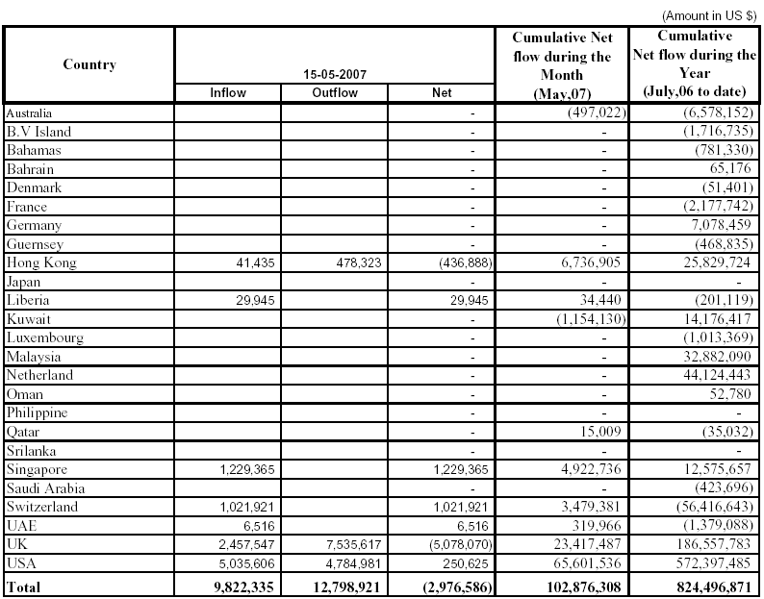

Note: The statement shows inflow (for investment in stock exchange and
Government securities) and outflow (Withdrawal) of SCRA maintained with Authorized Dealers (Ads) for portfolio investment.

14 – 5 Year Progress 2003 to 2007

In million except companies, index and bonds data.

5 YEARS PROGRESS
 | Upto  31-12-2003 | Upto  31-12-2004 | Upto  30-12-2005 | Upto  29-12-2006 | Upto  25-04-2007
Total No. of Listed Companies | 701 | 661 | 661 | 652 | 657
Total Listed Capital - Rs. | 313,267.23 | 405,646.32 | 470,427.47 | 519,270.17 | 599,725.35
Total Market Capitalisation - Rs. | 951,446.50 | 1,723,454.36 | 2,746,558.97 | 2,771,113.94 | 3,546,893.70
KSE-100 Index | 4471.60 | 6218.40 | 9556.61 | 10040.50 | 12166.03
KSE-30 Index |  |  |  | 12521.54 | 15028.99
KSE All Share Index | 2833.10 | 4104.86 | 6444.64 | 6770.06 | 8575.91
New Companies Listed during the year | 6 | 17 | 19 | 9 | 8
Listed Capital of New Companies - Rs. | 4,562.6 | 66,837.0 | 30,090.28 | 14,789.76 | 45,763.93
New Debt Instruments Listed during the year | 6 | 5 | 8 | 3 | 2
Listed Capital of New Debt Instruments - Rs. | 2,749.0 | 4,775.0 | 10,900.00 | 3,400.00 | 4,000.00
Average Daily Turnover - Shares in million | 308.81 | 343.70 | 365.64 | 260.69 | 223.82
Average value of daily turnover - Rs. | 15,686.23 | 17,408.95 | 33,583.29 | 31,610.71 | 22,771.13
Average Daily Turnover (Future) YTD | 54.06 | 69.64 | 117.16 | 82.68 | 68.54
Average Value of Daily Turnover - YTD | 3,906.69 | 4,914.25 | 15,461.42 | 13,587.63 | 9,887.26
Foreign Investment in Securities Market
Inflow - Rs | 11,256.5 | 1,481.1 * | - | - | -
Outflow - Rs | 10,705.3 | 3,047.9 | - | - | -
Net Inflow/(Outflow) - Rs | 551.2 | -1,566.7 | - | - | -

Glossary of Stock Market Terms

Stock Market – The market place where shares of publicly listed companies are bought and sold.

Stockbroker – A member of the stock exchange who deals in shares for clients and advises on investment decisions.

Bull – An investor who anticipates a rising market and, therefore, buys the security in the hope of selling it later at a higher price.

Bear – An investor who anticipates a falling market and, therefore, sells the security in the hope of buying it back at a lower price.

Blue Chip – A large well-established company with a history of profitable operation.

Bonds – Fixed-income securities, which entitle the holder to a pre-determined return during their life and repayment of principal at maturity.

Capital Gains Tax – Tax payable on profit arising from appreciation in value of investment, realized at the time of selling or maturity of investment.

Carry-over Trades – Equity repurchase transactions, better known, as “Badla”. These are an established form of transactions used in the stock market for temporary financing of trades by speculators and jobbers.

Dividend – That part of a company’s profits which is distributed among shareholders, usually expressed in rupee per share or percentage to paid up capital.

Earnings per share (EPS) – A profitability indicator calculated by dividing the earnings available to common stockholders during a period by the average number of shares actually outstanding at the end of that period.

Equity – The owners’ interest in a company’s capital usually referred to by ordinary shares.

Floatation – The occasion when a company’s shares are offered on the stock market for the first time.

Fund managers – A company, which invests and manages investors’ money, with the aim of maximizing capital growth.

Initial Public Offering (IPO) – The offering of equity shares of a company to the general public for the first time.

Insider trading – The purchase or sale of shares by someone who possesses ‘inside’ information on a company’s performance which information has not been made available to the market and which might affect the share price. In Pakistan, such deals are a criminal offence.

Investment companies – A company, which issues shares and uses its capital to buy securities and shares in other companies.

Listed company – A company whose securities are admitted for listing on a stock exchange.

Long position - When an individual purchases securities of a company he is said to have a long position in the company’s shares. For example an owner of shares in PTCL is said to be "long PTCL" or "has a long position in PTCL." If you are long, you would like the share price to go up.

Market capitalization – The total value of a company’s equity capital at the current market price.

Ordinary shares – The most common form of shares, which entitle the owners to jointly own the company. Holders may receive dividends depending on profitability of the company and recommendation of directors.

Portfolio – A collection of investments

Price/earning ratio (P/E ratio) – The P/E ratio is a measure of the level of confidence (rightly or wrongly) investors has in a company. It is calculated by dividing the current share price by the last published earnings per share.

Primary market – Where a company issues new shares, either for the first time, or at the time of issuing additional securities.

Privatization – Conversion of a state-owned company to a public limited company (plc) status.

Private company – A company that is not a public company and which is not allowed to offer its shares to the general public.

Public limited company (plc) – A company whose shares are offered to the general public and traded freely on the open market and whose share capital is not less than a statutory minimum.

Rights Issue – The issue of additional shares to existing shareholders when companies want to raise more capital.

Securities – A broad term for shares, corporate bonds or any other form of paper investment in capital market instruments.

Settlement – Once a deal has been made, the settlement process transfers stock from seller to buyer and arranges the corresponding exchange of money between buyer and seller.

Short Selling - The act of borrowing stock to sell with the expectation of price reduction with the intention of buying it back at a cheaper price.

Unit trust – An open-ended mutual fund that invests funds in securities and issues units for sale to the public. It can repurchase these units at any time.

Yield – The aggregate return earned on an investment taking into account the dividend/interest income and its present capital value.

Online Sources:

www.kse.net.pk
www.pkfinance.info
www.tezimandee.com
www.ksedata.com
www.lahorestock.com
www.kse100.info
www.investopedia.com
www.wikipedia.com
www.taurussecurities.com
www.kasbdirect.com
www.cdcpakistan.com

